Mosfet Selection

In order to select proper mosfet we looked at drain to source voltage rating and continuous current ratings. As seen Figure 7 at 48 volt imput mosfet voltage has 67 V peak value. Continuous current rating of mosfet is 13 A. From this calculations selected mosfet ratings are shown in Table 1.

|  |  |
| --- | --- |
| Product code | MTP20N15E |
| Drain−Source Voltage | 150 V (dc) |
| Drain − Continuous | 20 A (dc) / 12 A @ 100°C |
| Operating and Storage Temperature Range | −55 to 150 °C |
| Gate−Source Voltage | ± 20 V (dc) |
| Pruduct link | <https://www.onsemi.com/pub/Collateral/MTP20N15E-D.PDF> |

Diode selection

For the diode selection important parameters are peak inverse voltage and current capability.

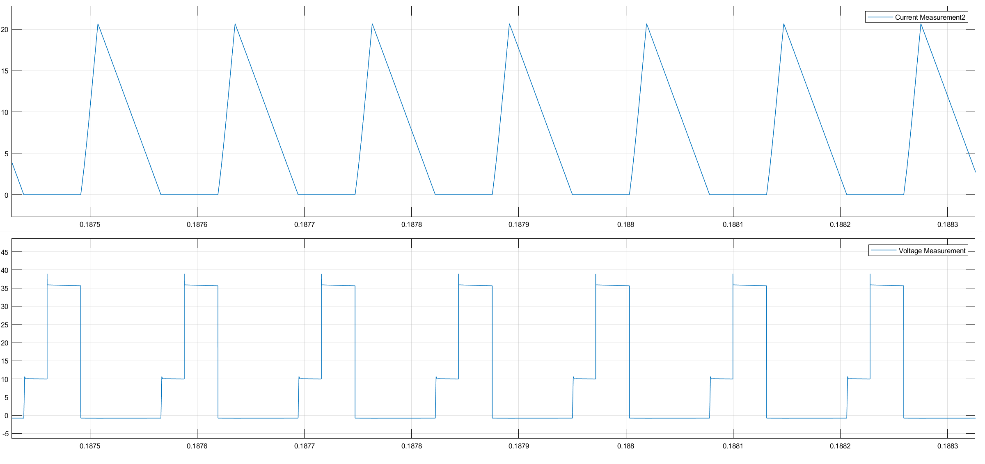

Figure X: Diode voltage and current ratings

From Figure X. We found peak inverse voltage as 40 V and continuous current as 22 A. Using these parameters a diode is selected and it’s parameters shown in table 2.

|  |  |
| --- | --- |
| Product Code | STPS30M100S |
| IF(AV) | 30 A |
| VRRM | 100 V |
| Tj (max.) | 150 °C |
| VF (typ. | 0.605 V |
| Product Link | <https://www.st.com/content/ccc/resource/technical/document/datasheet/e4/43/ab/35/b9/4b/41/c9/CD00228906.pdf/files/CD00228906.pdf/jcr:content/translations/en.CD00228906.pdf> |

Filter capacitor selection

At the outpu capacitor wer calculated that we need 3 680 uF capacitor. It is also known that our output voltage rating is 10 V. After finding these parameters we selected our capacitor whose parameters is seen at Table 3.

|  |  |
| --- | --- |
| Product code | PEG124MG368AQL1 |
| Capacitance | 680 µF |
| Voltage - Rated | 63 V |
| Ripple Current @ High Frequency | 7.5A @ 5kHz |
| Product Link | <https://content.kemet.com/datasheets/KEM_A4011_PEG124.pdf> |

Snubber Elements

Snubber Capacitor selection

In the simulation we found capacitor voltage and current ratings which are indicated in Figure X.

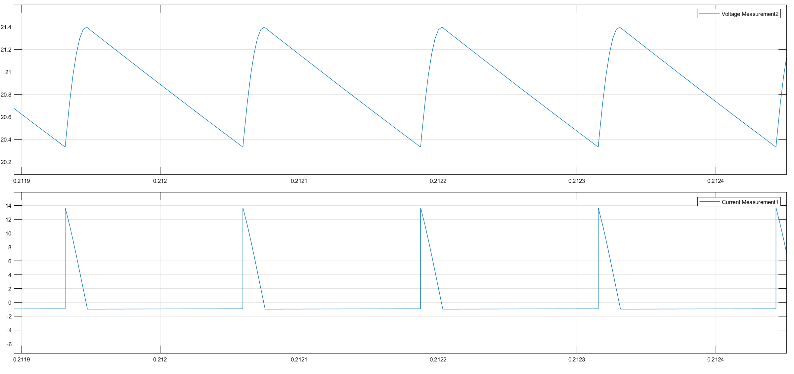

Figure X : Snubber capacitor voltage and current ratings

After determining these values an aluminum electrolytic capacitor is selected as seen in table 4.

|  |  |
| --- | --- |
| Product code | B41890A7107M |
| Capacitance | 100µF |
| Voltage - Rated | 35V |
| Product Link | <https://www.tdk-electronics.tdk.com/inf/20/30/db/aec/B41890.pdf> |

Snubber Diode

Similar to snubber capacitor selection by looking at its voltage and current rating a diode is selected. Simulation results are shown in Figure X.

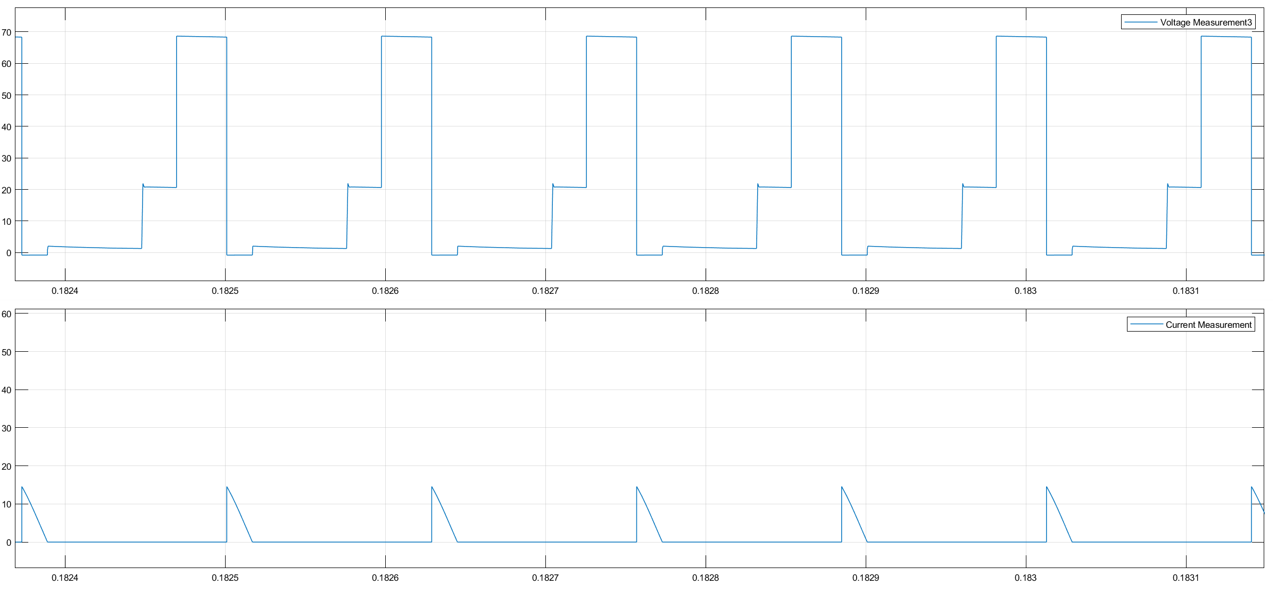

Figure : Snubber diode voltage and current ratings

Selected diode and its parameters indicated in Table 5.

|  |  |
| --- | --- |
| Product code | TST40L 150CW |
| IF(AV) | 20 A |
| VRRM | 150 V |
| Tj (max.) | 150 °C |
| VF (typ. | 0.86 V |
| Product Link | <https://www.taiwansemi.com/products/datasheet/TST40L100CW%20SERIES_B14.pdf> |